10-Feb-22

**Experiment 3 - NFA to DFA conversion**

Dhawal Patil

RA1911003010575

CSE A2

Aim:

Write A Program to convert given NFA to DFA.

Algorithm:

1. Get the input from the user
2. Set the only state in SDFA to “unmarked”.
3. While SDFA contains an unmarked state do -
   1. Assume T is that unmarked state
   2. For each a in % do S = e-closure(MoveNFA(T,a))
   3. If S is not SDFA already then, add S to SDFA (as unmarked state)
   4. Set MoveDFA(T,a) to S
4. For each S in SDFA if any s & S is a final state in the NFA then, mark S as final state in the DFA
5. Print the result

Code:

import pandas as pd

nfa = {}

n = int(input("No. of states : "))

t = int(input("No. of transitions : "))

for i in range(n):

state = input("state name : ")

nfa[state] = {}

for j in range(t):

path = input("path : ")

print("Enter end state from state {} travelling through path {} : ".format(state, path))

reaching_state = [x for x in input().split()]

nfa[state][path] = reaching_state

print("\nNFA :- \n")

print(nfa)

print("\nPrinting NFA table :- ")

nfa_table = pd.DataFrame(nfa)

print(nfa_table.transpose())

print("Enter final state of NFA : ")

nfa_final_state = [x for x in input().split()]

new_states_list = []

dfa = {}

keys_list = list(

list(nfa.keys())[0])

path_list = list(nfa[keys_list[0]].keys())

dfa[keys_list[0]] = {}

for y in range(t):

var = "".join(nfa[keys_list[0]][

path_list[y]])

dfa[keys_list[0]][path_list[y]] = var

if var not in keys_list:

new_states_list.append(var)

keys_list.append(var)

while len(new_states_list) != 0:

dfa[new_states_list[0]] = {}

for _ in range(len(new_states_list[0])):

for i in range(len(path_list)):

temp = []

for j in range(len(new_states_list[0])):

temp += nfa[new_states_list[0][j]][path_list[i]]

s = ""

s = s.join(temp)

if s not in keys_list:

new_states_list.append(s)

keys_list.append(s)

dfa[new_states_list[0]][path_list[i]] = s

new_states_list.remove(new_states_list[0])

print("\nDFA :- \n")

print(dfa)

print("\nPrinting DFA table :- ")

dfa_table = pd.DataFrame(dfa)

print(dfa_table.transpose())

dfa_states_list = list(dfa.keys())

dfa_final_states = []

for x in dfa_states_list:

for i in x:

if i in nfa_final_state:

dfa_final_states.append(x)

break

print("\nFinal states of the DFA are : ", dfa_final_states)

Output:

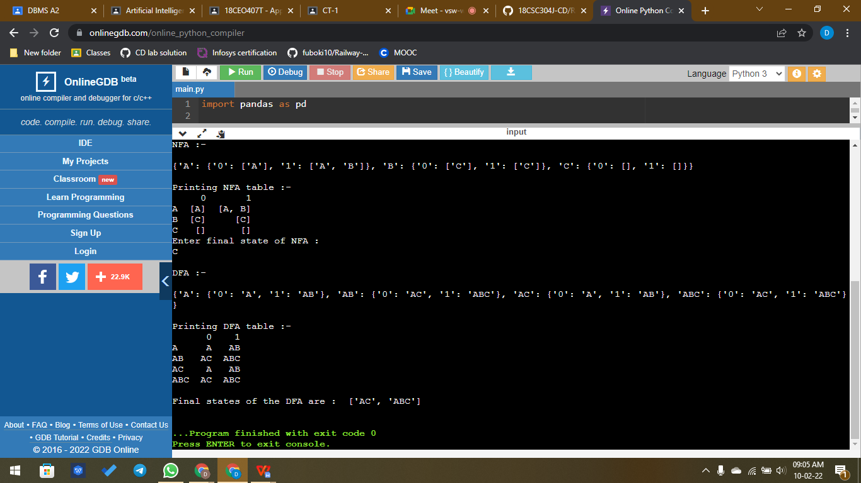

Result:

Hence conversion of NFA to DFA was successfully completed and the desired result was obtained.